**PROJECT 1**

**Implementing azure laas**

According to the problem statement following are the steps to implement this

* They have their headquarters in **East US** with another branch office in **SouthEast Asia, means in two different regions.**
* Now create one vnet in resource group named vnet1 ip be 10.0.0.0/16 in rgeu1 and vnet2 the ip be 192.168.0.0/16

in rgeu1

* Now create two virtual network gateway for both vnet
* For first virtual network gateway following fields should be filled as

Name : vng-vn1

Gateway type : vpn

Sku : default

VPN type: Route based

Virtual nw : vnet1

Public ip: create new with name pipvn1

* For second virtual network gateway following fields should be filled as

Name : vng-vn2

Gateway type : vpn

Sku : default

VPN type: Route based

Virtual nw : vnet2

Public ip: create new with name pipvn2

* Now configure virtual network gateway for configuring first click on virtual network gateway named vng-vn1 and click on connections -> click on add and filling the following fields
* Name:vng-ng1

Connection Type : vnet to vnet

First vnet gateway: Vnet1

Second vnet gateway: Vnet2

Shared Key : sk1

* Now configuring second click on virtual network gateway named vng-vn2 and click on connections -> click on add and filling the following fields

Name :vgn-ng2

Connection Type : vnet to vnet

First vnet gateway: Vnet2

Second vnet gateway: Vnet1

Shared Key : sk1 ( should be same in booth virtual network gateway)

* Now create one vitual machine in booth vnets, and make sure that firewall should be off so that two vitual machine in two different region should ping each other.
* Check the ip of two virtual machines and ping each other through respective virtual machines.

**Procedure for creating vnet and virtual machine is under following**

**Creating vnet:**

* Login to Azure Portal
* From Azure Services, select Virtual network

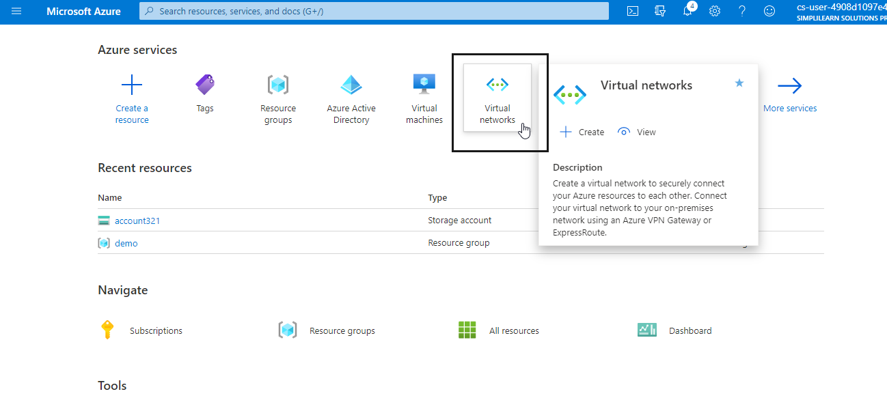

* Click on the **Add** button

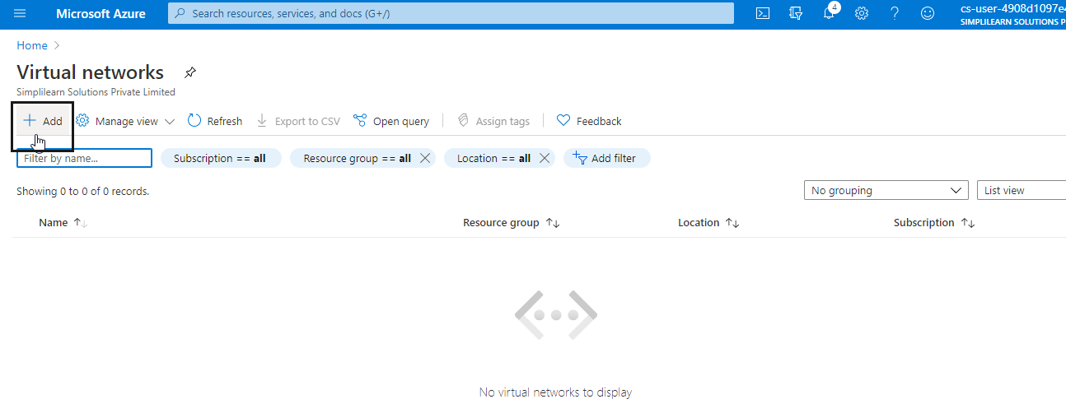

* Fill in the required information
* Select Resource group
* Select Virtual Network Name
* Select Location
* Click on the **Review+Create** button

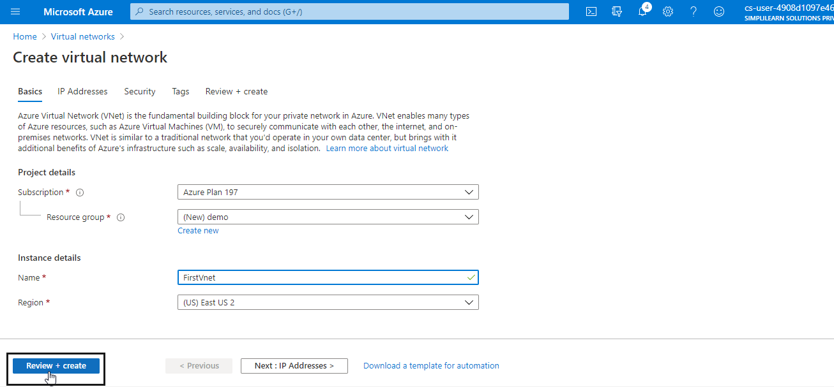

* Click on the **Create** button

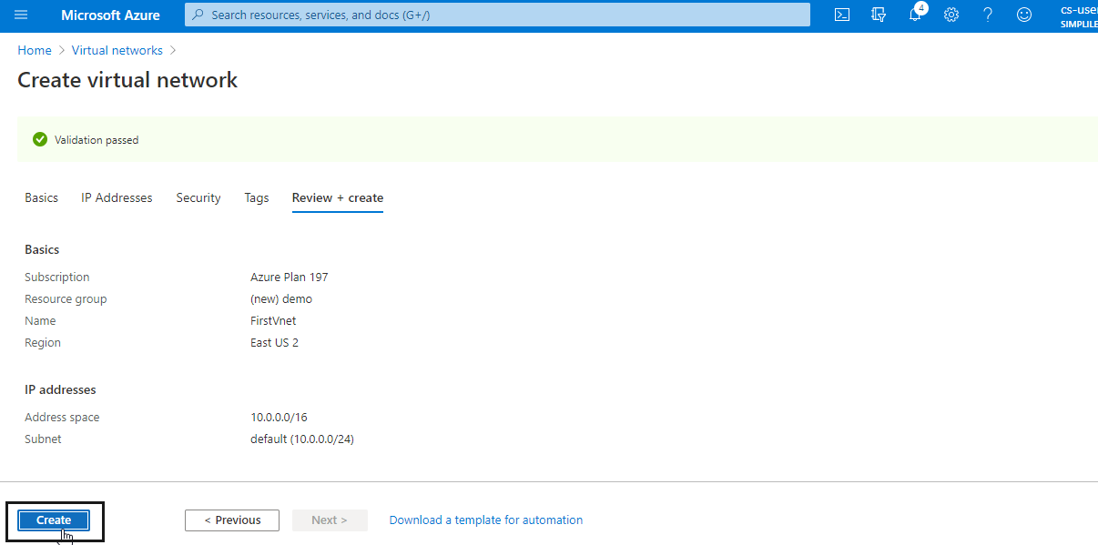

**Creating a Virtual Machine**

* Log into the Azure portal at https://portal.azure.com
* Type **virtual machines** in the search
* Under Services, select **Virtual machines**
* Click on **+ Add**
* In the Basics tab, under Project details, make sure the correct subscription is selected and then choose to **Create new resource group**. Enter **myResourceGroup** for the name
* Under instance details, type **myVM** for the virtual machine name and choose West US for your Region, and then choose Windows Server 2016 Datacenter for the image. Leave the other defaults
* Under Administrator account, provide a username, such as **azureuser** and a password. The password must be at least 12 characters long and meet the defined complexity requirements
* Under Inbound port rules, choose **Allow selected ports** and select RDP (3389) and **HTTP (80)** from the drop-down
* Leave the remaining defaults
* Click on **Review + create**
* After the validation passes, click on **Create**